**MAEER’s**



**TE MINI PROJECT REPORT**

**ON**

**SOIL NUTRIENT TESTER**

SUBMITTED BY,

**KHEMRAJ ANIL UBALE (T150023134)**

**AMAN PRITAM UMRE (T150023135)**

**VARAD NIRANJAN VAHIKAR (T150023136)**

Project Guide:

**Prof. NATHRAO JADHAV (Internal Guide)**

**TE DIV: II**

**Year: 2018-2019**

Department of Electronics and Telecommunication

Maharashtra Institute of Technology, Pune - 38.

**MAEER’s**



**MAHARASHTRA INSTITUTE OF TECHNOLOGY, PUNE.**

**CERTIFICATE**

This is to certify that the Project entitled

**SOIL NUTRIENT TESTER**

Has been carried out successfully by

**KHEMRAJ ANIL UBALE (T150023134)**

**AMAN PRITAM UMRE (T150023135)**

**VARAD NIRANJAN VAHIKAR (T150023136)**

during the Academic Year **2018-2019**

in partial fulfillment of their

course of study for Bachelor's Degree in

**Electronics and Telecommunication** as per the syllabus prescribed by the

**SPPU.**

**Prof. Nathrao B. Jadhav Prof. Dr. Bharat S. Chaudhari**

Internal Guide Head of Department

(Electronics & Telecommunication Engineering) MIT, Pune

**DECLARATION**

We the undersigned, declare that the work carried under

Project entitled

**SOIL NUTRIENT TESTER**

Has been carried out by us and it is being not implemented by any external agency/company that sells projects. We further declare that work submitted in the form of report is not been copied from any paper/thesis/site as it is. However existing methods/approaches from any paper/thesis/site are being cited and are been acknowledged in the reference section of this report.

We are aware that our failure to adhere the above, the Institute/University/Examiners can take strict action against us. In such a case, whatever action is taken, it would be binding on us.

|  |  |  |
| --- | --- | --- |
| **Roll no** | **Name of student** | **Signature with date** |
| 305077 | Khemraj Anil Ubale |  |
| 305078 | Aman Pritam Umre |  |
| 305079 | Varad Niranjan Vahikar |  |

Academic Year **2018-2019**

**ACKNOWLEDGEMENT**

A project is an opportunity for the student to practically implement theoretical concepts. It proves to be a learning platform for the students so that they can compete successfully in their professional life. However, in this entire journey of completing the project, we need proper guidance so as to avoid obvious mistakes.

We would like to thank our principal Prof. Dr. L. K. Kshirsagar for his constant encouragement. We would also like to thank out head of E&TC department Prof. Dr. B. S Choudhary.

We would thank our internal guide Prof. Nathrao Jadhav for his invaluable guidance and support for making this project a success. We would also like to thank Prof. V. M. Joshi for her profound help.

Lastly, our sincere thanks to all staff members and friends who helped us in all possible ways to make this project a success.

**PROJECT ABSTRACT**

It is very important to test soil before a crop production,especially for farmers.

Due to unawareness and time consuming procedure for soil testing most of the farmers tend to avoid testing of soil and directly buy fertilizers which are commonly available in shops, this leads to degradation of quality of soil. Thus For optimizing crop production appropriate fertilizer is very much necessary.

Aim of our project is to detect the quality of soil on the basis of primary nutrient by using LDR sensor, display soil testing report indicating appropriate use of fertilizers on LCD

For increasing nutritional balance of plants, exact amount of particular nutrients is needed to be provided to plants.Both over fertilizers and inappropriate fertilizers can affect the quality of soil.

|  |  |  |
| --- | --- | --- |
| INDEX | | |
| SR.NO | **TOPIC** | **PAGE NO.** |
| 1. | CHAPTER 1.  1.1 INDRODUCTION  1.2 SCOPE OF PROJECT  1.3 ORGANIZATION OF REPORT | 7 |
| 2. | CHAPTER 2.  2.1 REVIEW OF LITERATURE  2.2 PRESENT SCENARIO | 9 |
| 3 | CHAPTER 3.  3.1 SPECIFICATIONS  3.2 BLOCK DIAGRAM  3.3 SELECTION OF COMPONENTS  3.4 CIRCUIT DIAGRAM  3.5 SOFTWARE ALGORITHM  3.6 MODULAR FLOWCHART  3.7 SYSTEM FLOWCHART  3.8 SYSTEM ALGORITHM | 11 |
| 4. | CHAPTER 4.  4.1 PERFORMANCE EVALUTION OF THE SYSTEM  4.2 COMPONENTS LIST  4.3 BILL OF MATERIAL  4.4 CONCLUSION  4.5 APPENDIX I  4.6 APENDIX II  4.7 REFERANCE | 27 |

**1.1 INTRODUCTION:**

Soil is important factor for farmer, to get increase crop production farmer uses lots of fertilizer to boost his crops. So due to use of fertilizer in much more quantity , it might be happen that soil will lose its fertility, also crop production may reduce and after this soil will become unfertile and farmer will not take any crop in that soil . It’s happen due to lack of knowledge of soil nutrients. So, to solve this problem we build our project on this. So, the aim of our project is to find quantity of nutrients present in the soil and suggest that which fertilizer farmer should use in his soil, so he will boost his crop production without any harm.

**1.2 Scope of project:**

The objective of project is to detect nutrients present soil and suggest the appropriate fertilizer.

In this project, 5 tests are being performed on the soil which is as follows:

1. Nitrogen test

2. Potassium test

3. Phosphorous test

4. Ph level

5. Soil moisture test

These tests are performed on primary nutrient; we use soil testing material which is chemical powder and ldr sensor to get result.

**The scope of the project is restricted to test only primary nutrient of soil and soilmoisture andnot all nutrients.**

**1.3 ORGANIZATION OF THE REPORT:**

* Chapter 1:Introduction and scope

This chapter provides an overview of the basic functionality of the system and describes its scope of expansion

* Chapter 2: Literature Survey and present scenario

This chapter enlightens the literature survey of the work done in this field so far as well as the present scenario.

* Chapter 3:System Block Diagram and Flow Chart

Explains in detail the design and development process of the system. Includes system specifications block diagram, description of each block.

* Chapter 4: Algorithms and Result

It includes all the algorithms used in program, algorithm for system design then conclusion and reference mentioned.

**Chapter 2**

**2.1 REVIEW OF LITERATURE:**

While researching about how to detect primary nutrients in soil, we came across several research papers about condition required for farming, soil testing etc.

The scientist Dr Donald S. Loch provided meaningful research paper about chemical, physical and biological testaas with different samples of soils. This research paper explained the principal on which good soil testing is based, how the results should be interpreted, and what can realistically be expected of a soil test in turf situations. After analyzing this research paper we got the results of each test, dilute water extraction methods and cation exchange capacity. We learnt about some parameters like pH in the soil, data for organic carbon and organic matter data.[1]

Another scientist Sonikajha and Suneetha V. also provided us some ideas about measuring the nutrient in soil and it provides all the necessary information that is required in order to set the target for nutrient application. It also allows us to detect and monitors the changing parameters of soil. The result depends on quality of samples. In this research paper, the soil samples were collected from horticulture spot, lakeside, agriculture area and mountains are studies. For the estimation of total nitrogen, available Phosphorus, available potassium and exchangeable Calcium and Magnesium the methods used are Kjeldahl method, Bray’s or Olsen’s method, Flame photometric method and EDTA titration method respectively. [2]

Ashwin A., Chitragar, Sneha M. also provided a research paper focusing on analysis the content of nutrients present in soil are essential for healthy plant growth are needed in large amount. There are different concept of soil pH detection techniques and technology. Soil pH affects the soil physical, chemical and biological properties of soil. To detect pH and optical defuse reflectance sensing, electro chemical sensing and electroconductivity sensing methods used. Adding today’s technology to the world agricultural fields a real time embedded based soil analyzer can be developed with quick and reliable automated system. Which is used to analyze various soil nutrients with the help of pH value? [3]

**2.2 PRESENT SCENARIO:**

Presently the tests available are time consuming and costly thus most farmers avoid going for it. Most of the farmers just buy fertilizers which are commonly available in market at cost effective rate. Eventually this leads to degradation of soil due to over fertilization on wrong fertilizers; to prevent this appropriate use of fertilizers along with adequate quantity needs to be provided. This can be achieved on larger scale if we have a field kit giving results in less time.

The soil testing kit will help farmers in testing 5 parameters of soil and recommends nutrients specific fertilizer dose within short time and thus help them to achieve higher yields

**CHAPTER 3**

**3.1 PROJECT SPECIFICATIONS:**

The main aim is to develop a robust system which can use on field. So farmer need not go in agriculture lab wait for report. This system gives report within 10-15 minutes so, it’s not time consuming. Soil testing material and ldr sensors are used in project, soil testing material is basically chemical powder use for each test, ldr sensor use to detect color that form in test tube. Soil moisture sensor used to detect moisture level of soil also type of soil can be determined.

Platform / Language used:

* ATMEL STUDIO 7.0
* Z-FLASHER(AVR)
* EASY-EDA (online platform)

SOIL SAMPLE USED FOR PROJECT:

* LOAMY SOIL SAMPLE
* SAND SAMPLE
* BLACK SOIL SAMPLE

**3.2 BLOCK DIAGRAM:**

Soil sample + Water +Soil testing material

LDR sensor

Soil sample

Soil moisture sensor

Microcontroller:

**ATMEGA 32**

LM35 sensor

Display of report on LCD module

3.2.1 block diagram for ATMEGA32

Servo motor mechanism:

Servo motor 1

SG-90

4 LEDs for backlight

Servo motor 4SG-90

Microcontroller:

**ATMEGA 328p**

Servo motor 2

SG-90

Servo motor 3SG-90

3.2.2 block diagram for ATMEGA 328 P -PU

**3.3 SELECTION OF COMPONENTS:**

* Microcontroller : ATMEGA 32

1. High performance, low power, 8-bit microcontroller
2. Advanced RISC architecture
3. 40 pins are there
4. 8-channel, 10-bit ADC
5. Master/Slave SPI interfacing
6. Operating voltage 4.5V-5.5V
7. Speed grades – 0-16MHz
8. Supports in system programmer

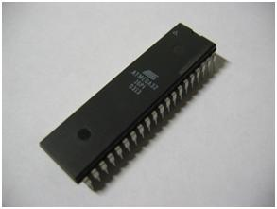

Figure 13.3.1 ATMEGA 32

ATMEGA 32 supports 8channels of ADC, for programming Atmel Studio used and for debugging Z-flasher used, operating voltage is 5V, it has 40 pins so, project requires 6 sensors, LCD display, and 5V operating voltage so these requirements are fulfilled by using ATMEGA 32.

* Microcontroller : ATMEGA 328P-PU
  + 1. High performance, low power, 8-bit microcontroller
    2. Advanced RISC architecture
    3. 28 pins are there
    4. 6 PWM channels
    5. Master/Slave SPI interfacing
    6. Operating voltage 4.5V-5.5V
    7. Speed grades – 0-20MHz
    8. Supports in system programmer

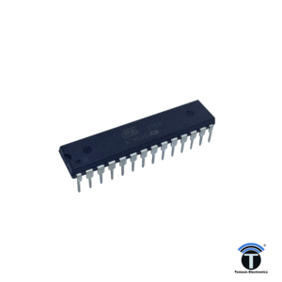

Figure 3.3.2 ATMEGA 328P-PU

ATMEGA 328 P_PU supports 6 PWM channels, for programming Atmel Studio used and for debugging Z-flasher used, operating voltage is 5V, it has 28 pins so, project requires 4 PWM channels, 5V operating voltage so these requirements are fulfilled by using ATMEGA 328 P_PU.

* Sensor : LDR sensor
  + 1. Easily available, cheap
    2. Easy interfacing
    3. Quick response
    4. Reliable performance

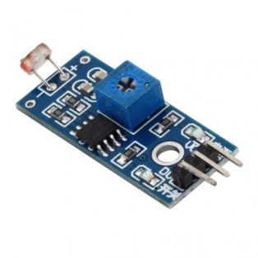

Figure 3.3.3 LDR SENSOR

LDR sensor sense light and vary its resistance, so as color is interfaced between LDR and light, light intensity will change and resistance will vary, it’s cheapest to detect color.

* Sensor : Soil moisture sensor

1. Sensitivity level adjustable
2. Threshold level can be adjustable
3. 5V operating voltage

Soil moisture sensor is based electro conductivity theorem, as there more nutrients present in soil conduction will more. Lm399 used to get proper ADC values

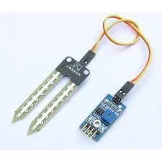

Figure 3.3.3 SOIL MOISTURE SENSOR

* Sensor : LM35 Temperature sensor

1. Easily available, cheap
2. Operating voltage - 5V
3. Calibrated directly in Celsius
4. 0.50C Ensured accuracy
5. Low self-heating

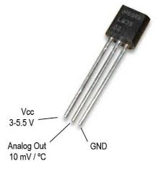

Figure 3.3.3 LM35 SENSOR

* Servo motor : SG-90
  + 1. Torque – 1.80 kg-cm
    2. Speed – 0.12/600
    3. Operating voltage - 5V
    4. Current require – 250mA(running current)

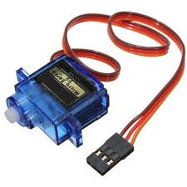

Figure 3.3.4 SERVO MOTOR

Sg-90 servo motor can operate by using varying p.m. and motor will move from 00 - 1800.cheaper and easy to interface.

* Power supply: AMS 1117 5.0V
  + 1. Low dropout voltage
    2. Load regulation 0.2%
    3. Output current up to 1A
    4. Output voltage up to 5V

As project require current of 1A and 5V dc regulated power supply this IC used in power supply

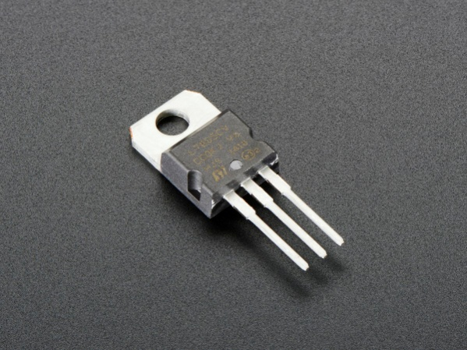

Figure 3.3.5 AMS 1117 5.0 TO-220

* Display : LCD 16*2
  + 1. 8 bit data can transfer
    2. Operating voltage – 5.0V
    3. Supply current – 2.5mA
    4. 5*7 dot matrix
    5. Power consumption – 12.5 mWatt

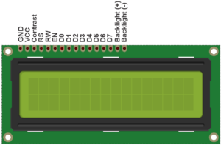

3.3.6 LCD DISPLAY

* Crystal oscillator circuit
  + 1. Pins XTAL1 and XTAL2 are for connecting resonant network to form oscillator. Typically quartz crystal and capacitors are employed
    2. 16 MHz of crystal and 33pF capacitors used.

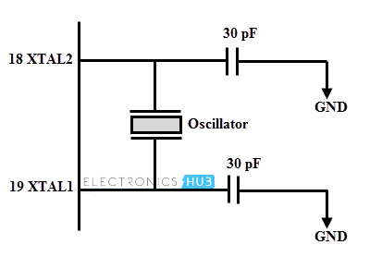

Figure 3.3.7 Crystal oscillator circuit

**3.4 CIRCUIT DIAGRAM:**

Schematics of PCB design:

ATMEGA 328 P-PU:

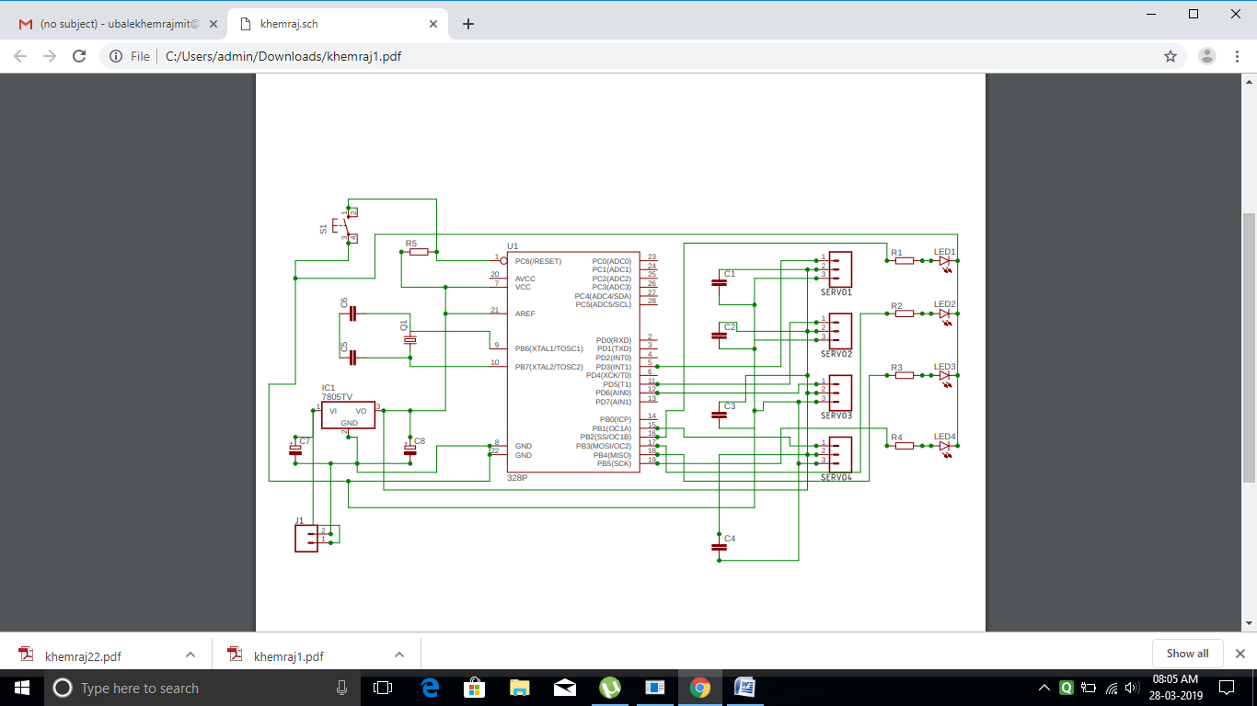

PCB design of ATMEGA 328P-PU:

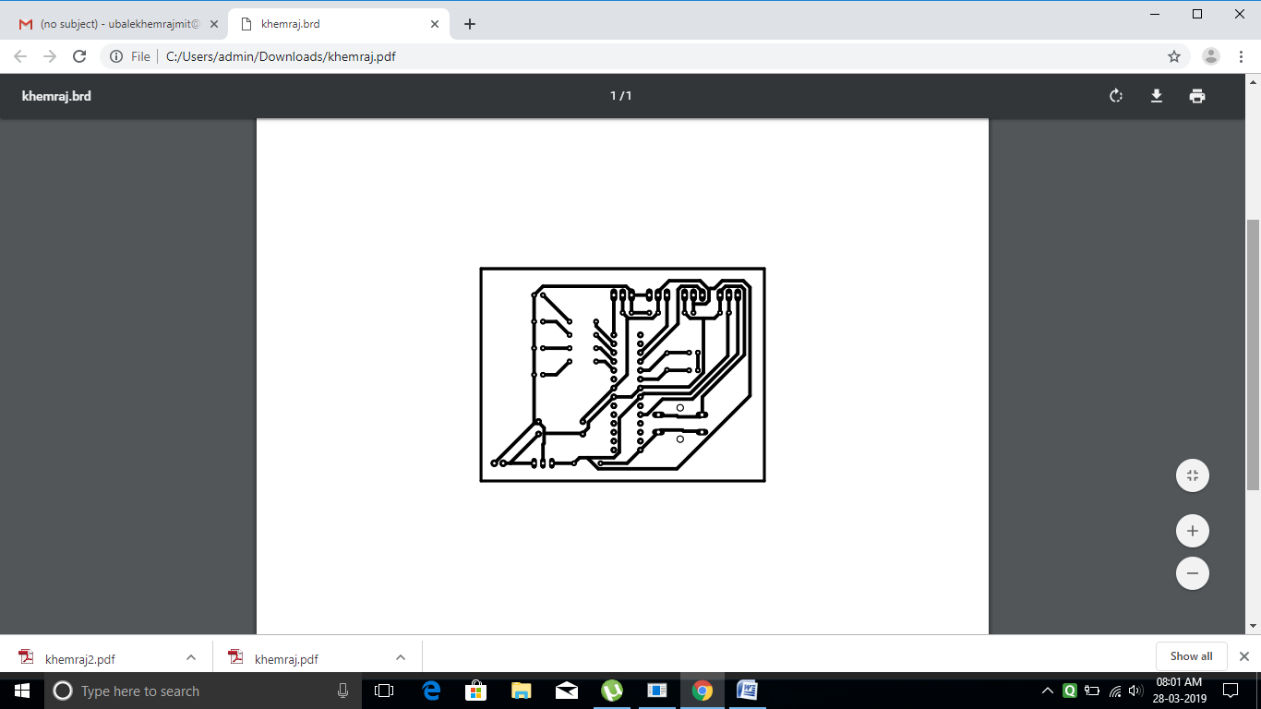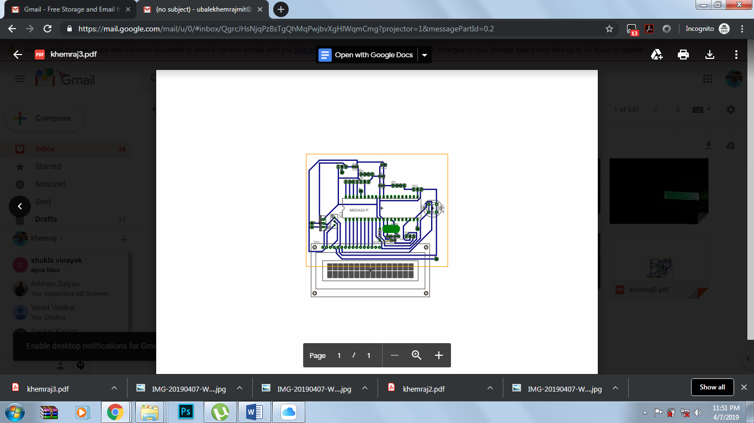

Schematic of ATMEGA 32:

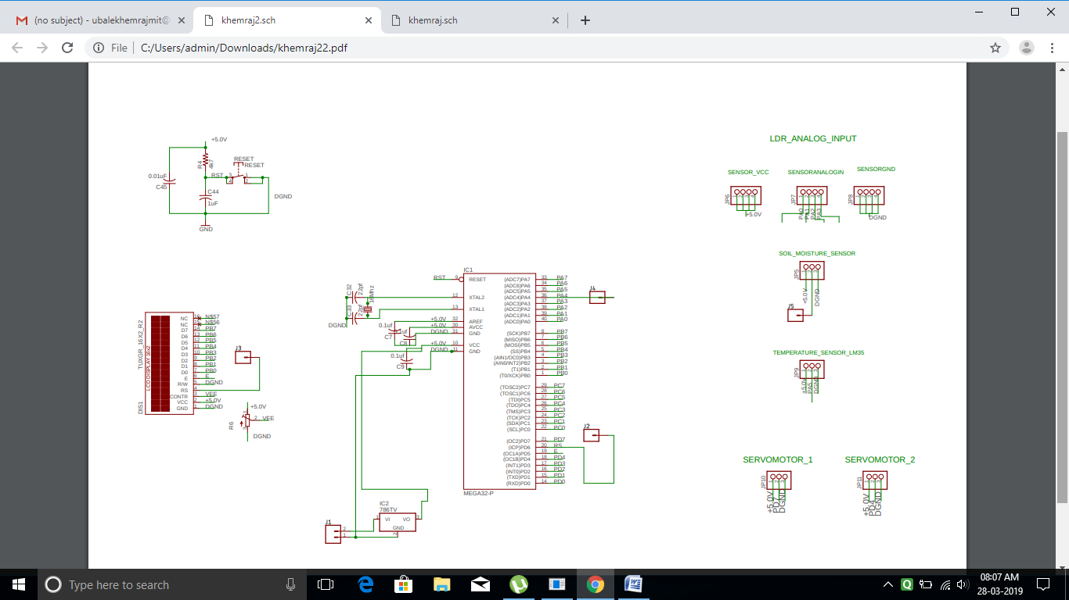

PCB design of ATMEGA 32:

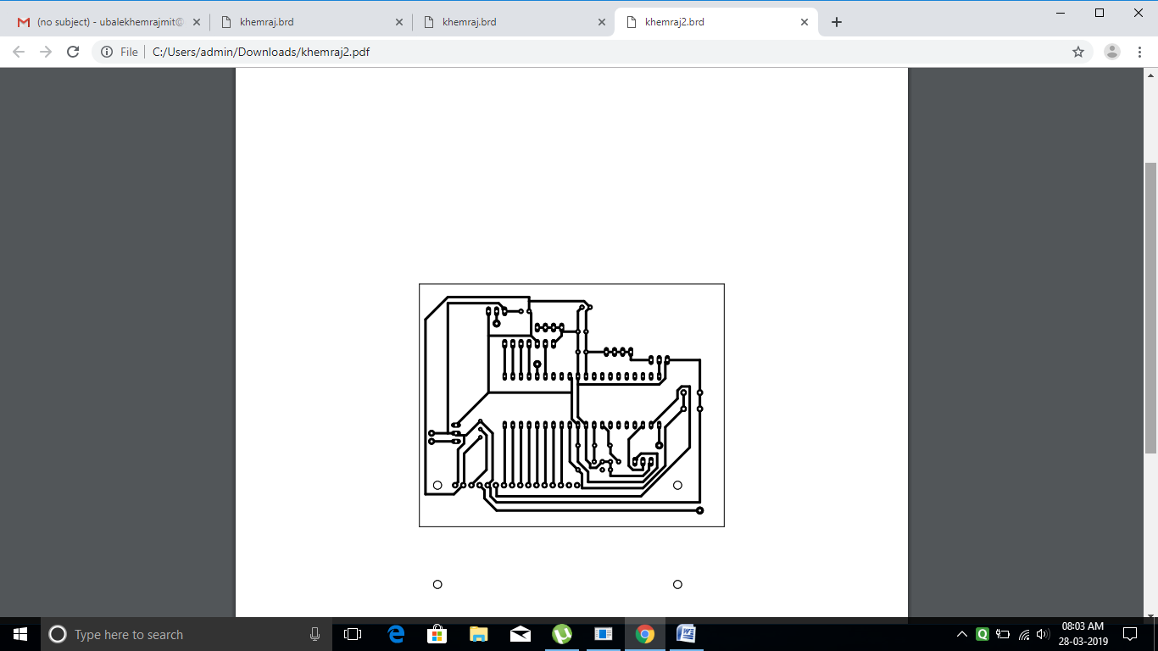 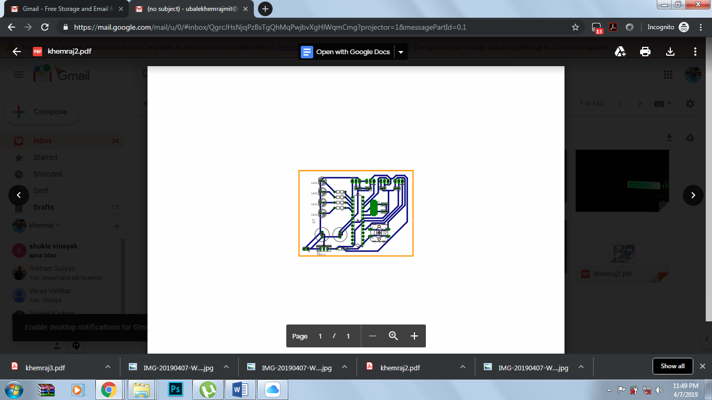

PIN DIAGRAM FOR ATMEGA 328 P-PU:

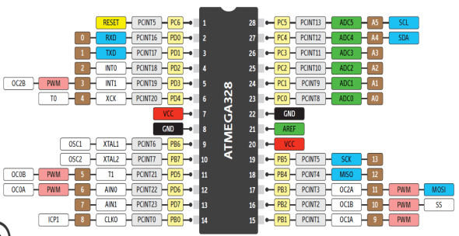

PIN DIAGRAM 32:

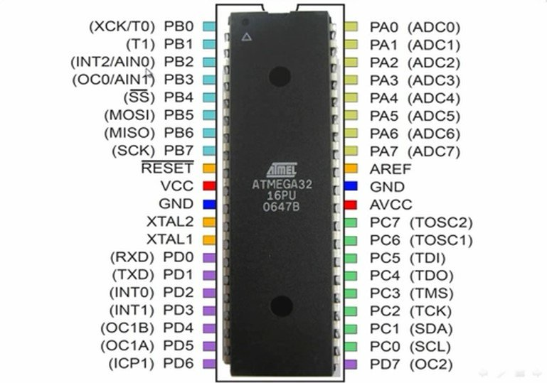

ATMEGA 32 connection:

|  |  |  |  |
| --- | --- | --- | --- |
| Pin number from microcontroller : | Component interface to respective pin : | Pin number from microcontroller : | Pin number from microcontroller : |
| PB0 | LCD D0 | PD6 | LCD RS |
| PB1 | LCD D1 | PD5 | LCD E |
| PB2 | LCD D2 | PA0 | LDR SENSOR 1(AOUT) |
| PB3 | LCD D3 | PA1 | LDR SENSOR 2(AOUT) |
| PB4 | LCD D4 | PA2 | LDR SENSOR 3(AOUT) |
| PB5 | LCD D5 | PA3 | LDR SENSOR 4(AOUT) |
| PB6 | LCD D6 | PA4 | SOIL MOISTURE SENSOR 1(AOUT) |
| PB7 | LCD D7 | PA5 | LM 35 TEMERATURE SENSOR 1(AOUT) |

ATMEGA 328P-PU connection:

|  |  |  |  |
| --- | --- | --- | --- |
| Pin number from microcontroller : | Component interface to respective pin : | Pin number from microcontroller : | Component interface to respective pin : |
| PD3 | SERVO MOTOR 1 (signal pin) | PB2 | LED1 |
| PD5 | SERVO MOTOR 2 (signal pin) | PB3 | LED2 |
| PD6 | SERVO MOTOR 3 (signal pin) | PB4 | LED3 |
| PB1 | SERVO MOTOR 4 (signal pin) | PB5 | LED4 |

**3.5 MODULAR FLOWCHART:**

3.5.1 FLOWCHART 1:

LDR SENSOR:

IF ADMUX = 0X60

LDR SENSOR 1 STARTS TO READ VALUES

REPEAT THIS PROCESS FOR 3 LDR SENSOR WITH ADMUX = 0X61 ADMUX = 0X62 ADMUX = 0X63

ATMEGA 32 COMPARES ANALOG VALUE WITH TEMPLATE VALUES AND SENDDATA TO LCD

LCD DISPLAY LEVELS OF NUTRIENTS AND FERTILIZER

Figure 3.6.1 Modular design for ldr sensor

3.5.2 MODULAR ALGORITHM:

Atmel Studio software is used for programming ATMEGA 32 and ATMEGA 328P-P;there are 6 functions that are defined in program for sensors and 3 functions for LCD display in ATMEGA 32 microcontroller, 4 functions for interfacing servo motors and 4 general purpose pins for LED defined in ATMEGA 328P-PU microcontroller.

Algorithm for ATMEGA 32

1. declare 9 functions and define macros, declared functions.
2. then define main function
3. In main function data direction registers and port pin registers are defined and then appropriate ADC registers are defined to use ADC channels.
4. In while loop functions were called for reading ADC value of respective channels and display appropriate output
5. _delay_ms() function which is in built function were called in between every sensor function to avoid noise while reading ADC channels.
6. Then 6 function are defined for 6 sensor to get ADC value and to display appropriate output
7. Then there are three functions are defined to use LCD display.

MODULAR FLOWCHART2:

SG-90 SERVO MOTOR:

SET TIMER 0 REGISTERS COM0A AND COM0B

REPEAT THIS PROCESS FOR SETTING TIMER2 REGISTERS AND OC2A, OC2B

IF OC0A, OC0B = 53, 153, 250

SERVO MOTOR 1,2 STARTS

Figure 3.6.2 Modular design for servo motor

MODULAR ALGORITHM 2:

1. 4 functions are declared to use PWM pins for interfacing servo motors functions are as follows -
2. Then main function defined in which timer register are configured to use PWM channels
3. Also data direction registers and port pin are defined for configuring LEDs and servo motor signal pins.
4. In while loop port pins are configured and servo motor functions are called
5. Lastly functions for configuring servo motors are defined.

**3.7 SYSTEM FLOWCHART:**

Input soil sample

1. Soil sample
2. Water
3. Soil testing material

Mixer

1. Servo motors

Shaking of sample

1. LDR sensor
2. LEDs (backlight)

Detection of color

1. LM 35
2. Soil moisture sensor
3. Soil sample

Detection of moisture, measurement of temperature

Display of report on LCD.

Figure 3.7.1: System block diagram

SYSTEM ALGORITHM:

First take soil sample, remove unwanted parts like small stones and other thing so it will be easy to get good results, then mix water with soil sample and soil testing material in test tube, put that test tube in soil nutrient tester, then test tubes will shake by servo motor mechanism that made in tester, after some time of shaking test tube LDR sensor will detect color, there will be a LED present near to test tube, the intensity of LED light will change due to color present in test tube, so that variation will detect by LDR sensor, then by using soil moisture sensor moisture level of soil can be determined also soil type can be determined and temperature of environment can be detected by using LM35 sensor. Lastly all the test report will be display on LCD module and appropriate fertilizer will be suggested.

**CHAPTER 4**

**4.1 PERFORMANCE EVALUTION:**

After back-testing on practical setup,we found adequate accuracy with the theoretical observations. The chemical reactions provided near about accurate results, as stated in theoretical chemical reactions performed in lab. LDR sensor detected and evaluated the analog readings as expected giving accuracy in determining the final end result

To analyze the concentration of each nutrient, a chemical reagent will be used to color each sample with an increase in color intensity indicating increased concentration of the nutrient.

1. For nitrogen testing nitrate compound use to detect nitrogen and reaction is

NO3-  +  Cd  +  2 H+  →  NO2- +  Cd2+  +  H2O

1. For detection of phosphorus, sodium molydate, and potassium pyrosulfate in the purchased PhosVer 3 reagent powder react with the soluble reactive phosphates to form a phospho-molybdate complex.

                                             H2PO4- + 12 Na2MoO4 +  → PMo12O403-

The complex is then reduced by ascorbic acid (also contained in PhosVer 3 powder) to form a molybdenum blue color. The blue color is quantified using a phosphate color comparator box with a continuous phosphate blue color disk.

1. In the potassium tests, the potassium ions combine with sodium tetraphenylborate contained in the purchased Potassium 3 reagent powder to form potassium tetraphenylborate, a white precipitate. The precipitate remains in suspension in samples, causing an increase in turbidity.

                                             NO3-  +  Cd  +  2 H+  NaB(C6H5)4 + K+ → KB(C6H5)4 + Na+

1. CaCl2is used to detect ph level in soil , pinkish yellow color will form in for acidic sample and bluish yellow color for alkaline compounds.

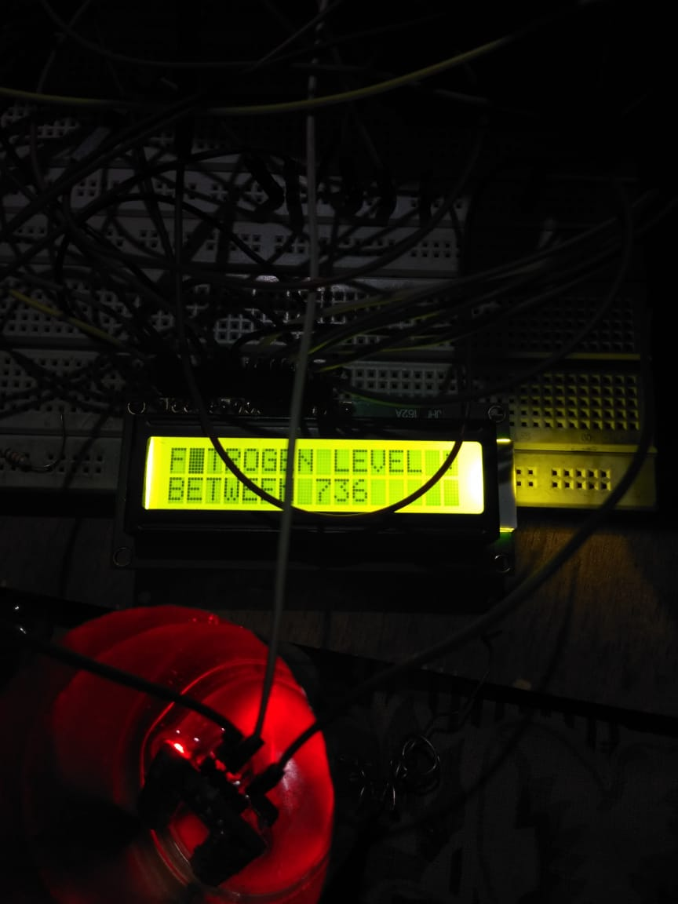

**4.2 COMPONENT LIST:**

**4.2.1 ELECTRONIC COMPONENTS:**

1. ATMEGA 32
2. ATMEGA 328P-PU
3. 4*LDR sensor
4. Soil moisture sensor
5. LM35 temperature sensor
6. 4*Servo motors
7. 4*LEDs
8. LCD display
9. Jumper wires
10. Resistors
11. Capacitors
12. Header pins
13. Dip of 40, 28
14. DMM
15. AMS 1117 5.0V

**4.2.2 HARDWARE COMPONENTS**

1. PVC sheets
2. Nut and bolts
3. Cutter
4. Injections
5. Test tubes
6. Soldering gun
7. Glue gun
8. PCB
9. Plywood

**4.3 COMPONENT BILLING:**

|  |  |  |  |
| --- | --- | --- | --- |
| SR. NO. | COMPONENT | QUANTITY | PRICE |
| 1. | SERVO MOTOR | 4 | 716 |
| 2. | LDR SENSOR | 4 | 308 |
| 3. | SOIL MOISTURE SENSOR | 1 | 164 |
| 4. | LM 35 | 2 | 192 |
| 5. | ATMEGA 32 | 2 | 282 |
| 6. | ATMEGA 328P-PU | 2 | 487 |
| 7. | DIP 40, 28 | 2 | 26 |
| 8. | CAPACITORS | 20 | 20 |
| 9. | RESISTORS | 20 | 20 |
| 10. | LEDS | 8 | 41 |
| 11. | PCB MANUFACTURE | 2 | 400 |
| 12. | JUMPER WIRES | 50 | 256 |
| 13. | LCD | 1 | 231 |
| 14. | CRYSTAL OSCILLATORS | 2 | 30 |
| 15. | SOIL TESTING MATERIAL | 1 | 680 |
| 16. | PVC SHEETS(2FT * 1FT) | 6 | 308 |
| 17. | NUT AND BOLTS | 20 | 40 |
| 18. | PLYWOOD(0.4M *0.2M) | 1 | 50 |
| 19. | USB ISP | 1 | 256 |
| 20. | AMS 1117 5.V | 2 | 130 |
| 21. | BATTERY(9V) | 3 | 75 |
|  | TOTAL |  | 4712 |

**4.4 CONCLUSION:**

In this project, we have tested soil for its nutritional value based on certain parameters and concluded the result in the form of required fertilizers for optimum production of certain crop in that soil.

Chemical reaction of the soil testing material with soil give certain color when mixed in water and shacked ,this color is detected through ldr sensor and is given as input to processor which then compares this analog value with ideal value for soil and gives output. This output indicates levels of nutrients present in soil, thus suggesting appropriate quantity of nutrients in the fertilizer

**4.5 APPENDIX I:**

1. ATMEGA 32:
   1. Voltage require 4.5V – 5.5V
   2. 6 ADC channels are used
2. ATMEGA 328 P-PU:
   1. Voltage require 2.7V – 5.0V
   2. 4 PWN channels are used
3. LDR sensor readings for each test:
   1. Ph level:
      1. Ph 4.0 – 530 +10
      2. Ph 4.5 – 550 +10
      3. Ph 5.0 – 570 +10
      4. Ph 5.5 – 590 +10
      5. Ph 6.0 – 610 +10
      6. Ph 6.5 – 630 +10
      7. Ph 7.0 – 650 +10
      8. Ph 7.5 – 670 + 10
      9. Ph 8.0 – 690 +10
      10. Ph 8.5 – 710 +10
      11. Ph 9.0 – 730 +10
      12. Ph 9.5 – 750 +10
      13. Ph 10.0 – 770 + 10
      14. Ph 10.5 – 790 +10
      15. Ph 11 – 810 +10
   2. Nitrogen level
      1. High level 85% - 95% - 730 +30
      2. Medium level 65%-85% - 660 +30
      3. Low level 35% - 60% - 580 + 30
      4. Lowest level 10% - 35% - 520 + 30
   3. phosphorous level
      1. High level 85% - 95% - 530 +30
      2. Medium level 65%-85% - 470 +30
      3. Low level 35% - 60% - 430 + 30
      4. Lowest level 10% - 35% - 370 + 30
   4. potassium level
      1. High level 85% - 95% - 630 +30
      2. Medium level 65%-85% - 580 +30
      3. Low level 35% - 60% - 520 + 30
      4. Lowest level 10% - 35% - 460 + 30
4. Soil moisture sensor
   1. Soil type
      1. Loamy sand 28.7% - 176 + 20
      2. Loam 32.5% - 330 + 20
      3. Slit loam 50.4% - 516 + 30
      4. Clay 42.8% - 438 + 30
5. LDR sensor:
   1. Vin = 5V
   2. Vout = Vin*(R2/(Rldr + R2)
   3. Resistor R2taken as 1kohm
   4. Resolution is 2.56V/1023
6. Servo motor:
   1. Voltage require 5V
   2. Current require 250mA(running current)
   3. There are 4 servo motors so, current requirement is 4*250mA = 1Atotal current require
   4. Capacitor of 100nF used to increase charging and discharging time
7. LED:
   1. Voltage require 3.3V
   2. Current require 20mA
   3. There are 4 LEDs are use so, 4*15mA = 60mA total current require
   4. Voltage from power supply is 5V to reduced it to 3.3V resistor is used
   5. Voltage / current = 3.3V / 15mA = 220ohm
   6. 220ohm resistor used to get 3.3V
8. Power supply:
   1. AMS 1117 5.0V IC used get DC regulated voltage
      1. 5V<Vin <12, hence Vin taken as 9V
      2. 10mA < Iout <= 1A, as system require current of 1A

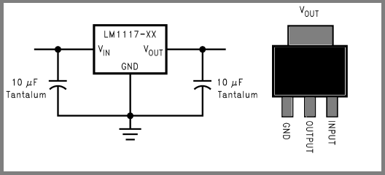

**\**

**SYSTEM PHOTOS:**

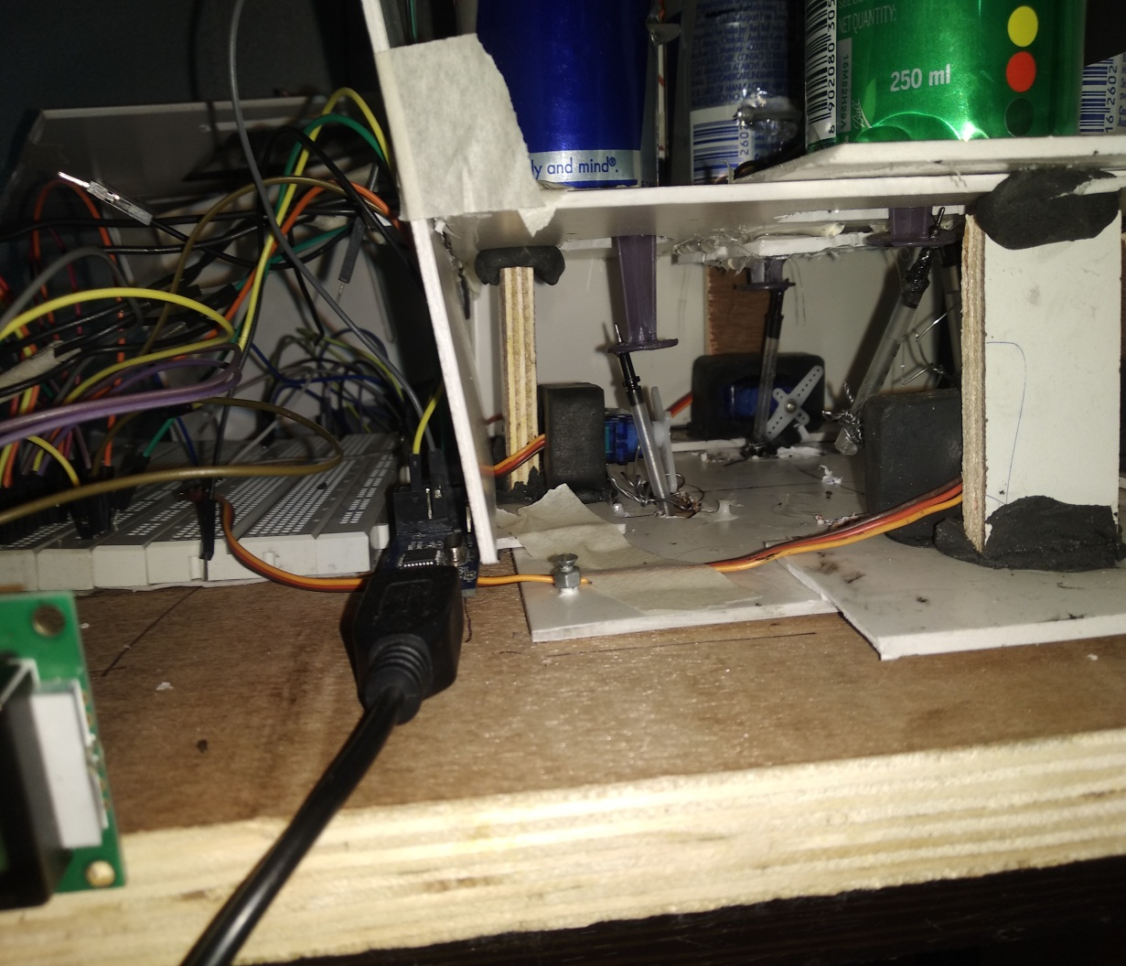

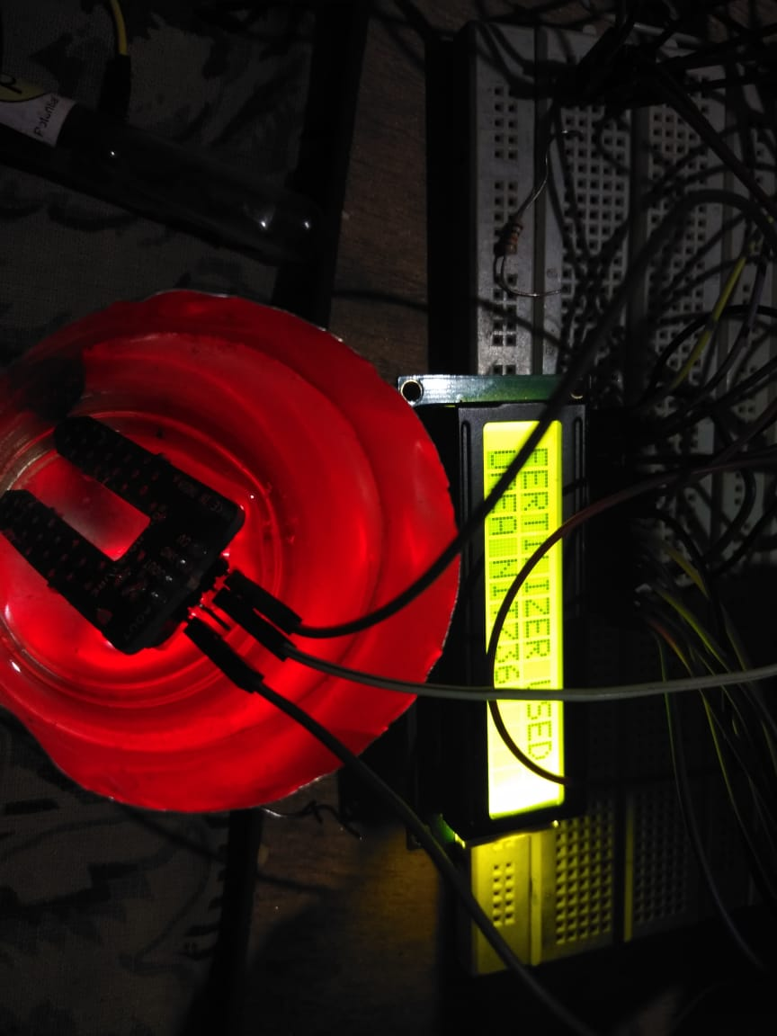

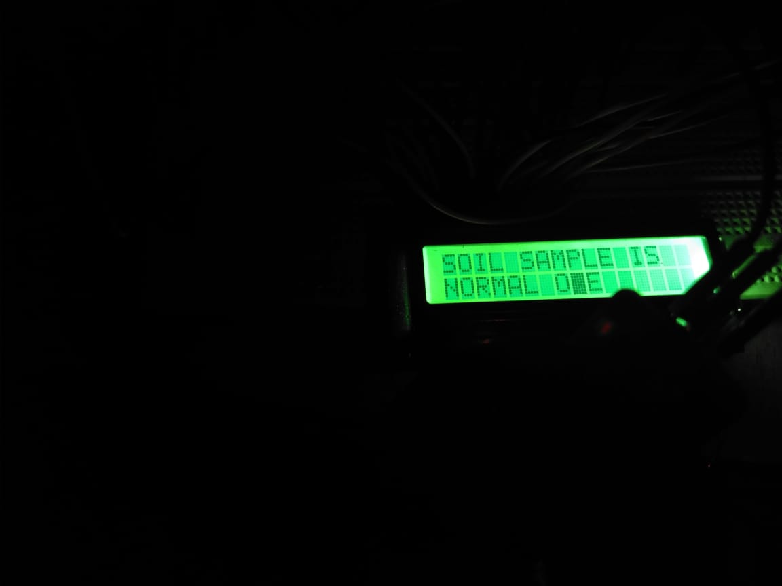

**4.6 APENDIX II:**

Datasheets

1. ATMEGA32
2. ATMEGA 328P-PU
3. Soil moisture sensor
4. AMS 1117 5.0V
5. LM 35 temperature sensor
6. Servo motor SG - 90

**4.7 REFERRANCE:**

[1] Allen V. Barker; D. J. Pilbeam (2007). [Handbook of plant nutrition](https://books.google.com/?id=ZWjLBQAAQBAJ). CRC Press. [ISBN](https://en.wikipedia.org/wiki/International_Standard_Book_Number) [978-0-8247-5904-9](https://en.wikipedia.org/wiki/Special:BookSources/978-0-8247-5904-9). Retrieved 17 August 2010.

[2]Pages 68 and 69 Taiz and Zeiger Plant Physiology 3rd Edition 2002 [ISBN](https://en.wikipedia.org/wiki/International_Standard_Book_Number) [0-87893-823-0](https://en.wikipedia.org/wiki/Special:BookSources/0-87893-823-0)

[3]Pages 26, 45 to 47 Soil Nutrient Testing: How to Get Meaningful Results, Dr Donald S. Loch

[4]Soil testing – Georgia FFA brochure

[5] Session 2 understanding soil nutrients